**\*\*Remember to ask professor for new york forced market as a reference for this project.**

CE153 Project

A study of a “forced market” to minimalize airline delays in [region] airport system:

Helping relieve congestion/delays at LAX by re-directing flights to other 4 LA area airports

Primary Research Question: How should LA air traffic be redistributed among the 5 major LA airports to minimize delays and what incentives would be required to achieve that distribution?

**Proposal:**

Our project is to investigate the capacity and limitations of the 5 Los Angeles area airports (LAX, LGB, SNA, ONT, BUR) and determine a way to optimally redistribute traffic among them for the primary purpose of reducing delays and associated carbon footprint. Two of these airports already cooperate to some extent under LAWA (Los Angeles World Airports, LAX and ONT). However the other three are separate entities, and all are subject to market forces. We will be considering a situation where all five airports are able to cooperate to determine and implement the most efficient traffic distribution and what incentives would be required to achieve that distribution.

By reducing airline delays, passengers may enjoy a smoother traffic experience, aircraft fuel burn may be reduced, and air travel carbon footprint will be reduced.

However, implementing such traffic redistribution will come with costs, including possible increased total travel time, increased fare, and increased psychological/convenience costs. The study will seek to determine what incentives are necessary to encourage travelers to follow the offerings of the redistributed traffic.

**Project Ideas**

* What about a study on cooperation among the 5 LA airports.
  + Determine the limitations on expansion and capacity for each airport. Research major challenges each one faces and consider scenarios where airports expand to optimize further.
* Working with SCT (Southern California TRACON)

**Possible Databases**

* ASPM (Aviation Systems Performance Modeling) - Wheels down to gate docking
* Sabre (Semi-automated Business Research Environment) database
* BTS (Bureau of Transportation Statistics) Publicly available
* ICAO (International Civil Aviation Organization) Database

**Possible Data Sets**

* Which airports planes fly in to
* What time these planes fly in
* What aircraft type the airlines will use

**Defining “What we can improve”**

* Reducing/balance flight delays and travel time
* Reducing fuel expenses / carbon footprint
* Opportunities for operation improvement/expansion at the smaller airports
* Opportunities for LAX to transition to lower volume, higher density international traffic, and incentivize distribution of domestic traffic throughout the basin.
* What kind of incentives to passengers, airlines, communities, would be required for this to happen
* How changing flight (market) distribution will increase costs (travel time, transit time, convenience costs)

**Consider**

* Changing direct/nonstop to hub-and-spoke routes (help reduce carbon footprint) à greater load factors à research aircraft fuel performance
* Different communities’ perspectives on carbon footprints
* Ways to compute carbon footprint based on other factors (ex. flight time, aircraft type, ground delays)
  + Includes average fuel cost of taxi time, delays, flight length,
* What the main source of delays at LAX is (runway congestions vs gate congestion, probably the latter) and identifying other limiting factors that could pose a problem in any attempt to expand operations
* Possibly improving landside facilities such as adding a people mover similar to AirBART in between the crenshaw line (in construction) and the terminal.

**Resources**

* Live Tracking LA airspace traffic: <http://www.lawa.org/welcome_LAX.aspx?id=792>
* LAX Specific Flight Tracker: <http://flightaware.com/live/airport/KLAX>
* Singular picture of LAX arrival and departure routes <http://www.lawa.org/welcome_LAX.aspx?id=11482>
* Projected LA Metro routes by 2040 <http://a.scpr.org/i/original/78380-full.jpg>
* Current LA Metro routes <http://media.metro.net/riding_metro/maps/images/rail_map.pdf>
* VFR Map: <http://vfrmap.com/>
* John Wayne Statistics <http://www.ocair.com/newsroom/news/airportstats>
* Aircraft fuel economy <https://en.wikipedia.org/wiki/Fuel_economy_in_aircraft>
* Fuel Savings <http://apex.aero/wp-content/uploads/2014/11/APEX-Airline-Fuel.pdf>
* Metroplex flight path fact sheet: <https://www.lawa.org/uploadedFiles/LAX/noise/FAA%20Metroplex%20Fact%20Sheet%20150817%20Update.pdf>
* LAX carrier market shares <http://www.lawa.org/LAXMarketShare.aspx>
* LAX Passengers survey (2006) : <https://www.lawa.org/uploadedfiles/lax/pdf/2006LAXPassengerSurveyFinal.pdf>
* LAX Passengers survey (2011) : <https://www.lawa.org/uploadedFiles/OurLAX/pdf/LAX_Survey_Final_Draft_REPORT_2012_08_19.pdf>
* LAX Monthly Statistics Page: <http://www.lawa.org/LAXStatistics.aspx>
* Distance Calculator by Address for all 5 airports: <http://www.flyontario.com/trip-calculator.asp>
* LAX Metroplex: <http://www.lawa.org/welcome_lax.aspx?id=12168v>
* FAA LAX Metroplex: <http://www.metroplexenvironmental.com/socal_metroplex/socal_introduction.html>
* <https://www.nbaa.org/ops/airports/20140527-business-aviation-capacity-looks-good-at-los-angeles-area-airports.php> Opportunities for air traffic increases at other basin airports
* <http://centreforaviation.com/analysis/los-angeles-international-airport-competition-creates-its-challenges-50232> efforts to diffuse passengers; estimated 75
* <https://www.faa.gov/airports/planning_capacity/profiles/media/Airport-Capacity-Profiles-2014.pdf> Airport capacity profiles 2014. Los Angeles International Visibl167-176 147-153 133-143
* <https://en.wikipedia.org/wiki/Southern_California_TRACON> TRACON organization
* <http://www.lawa.org/uploadedfiles/spas/pdf/SPAS%20REPORT/LAX%20SPAS%20Report%20App%20F-2%20Alt%20SIMMOD%20Simulation%20Final.pdf> LAX air routes and Tracon data

**Airport Quick Facts**

* Bob Hope (BUR)
  + Gates: 14
  + Total Operations: 130,756
  + Yearly Passengers: 3,943,629
  + Runway Lengths
    - 15: 6886x150
    - 8 : 5801x150
  + Hours: 5:30 am -10 pm
* Los Angeles (LAX)
  + Gates: 121
  + Aircraft Operations (2015): 655,564
  + Yearly Passengers (2015): 74,937,004
  + Runway Lengths
    - 24R: 8925x150
    - 24L: 10285x150
    - 25R: 12091x150
    - 25L: 11096x200
  + Hours: Approximately 4am - 1 am every day
* Long Beach (LGB)
  + Gates: 11
  + Aircraft Operations: 304,720
  + Yearly Passengers: 2,523,686
  + Runway Lengths
    - 25L: 5423x150
    - 25R: 6192x150
    - 30: 10000x200
  + Hours: 7am - 10pm
    - The city has a noise budget (<http://www.lgb.org/information/noise_abatement/frequently_asked_questions.asp>)
* Ontario (ONT)
  + Gates: 19
  + Yearly Passengers: 4,209,311
  + Runway Lengths
    - 26R: 12198x150
    - 26L: 10200x150
  + Services
    - 15 Cities
    - 64 Daily nonstop flights
* John Wayne (SNA)
  + Gates: 26
  + Daily Passengers:
  + Annual Passengers: 10,180,258
  + Total Operations: 260,689
  + GA Operations: 174,989
  + Runway Length:
    - 19R: 5700x150
  + Hours: 5am - 1am

**EXAMPLE**

5 airports

3 flights per day from San Francisco to each of 5 LA airports

each plane can carry 100 pax

each flight is only 80% filled (80pax)

à 1500 seats offered per day

à 1200 seats are filled each day (every passenger will fly on new schedule/frequency if given appropriate incentives)

difference is 300 seats

-----------

get rid of 3 flights, a 1200 seats offered, 1200 seats filled, 100% load factor

**Hubs LA would distribute to**

Denver

Chicago

San Francisco

New York

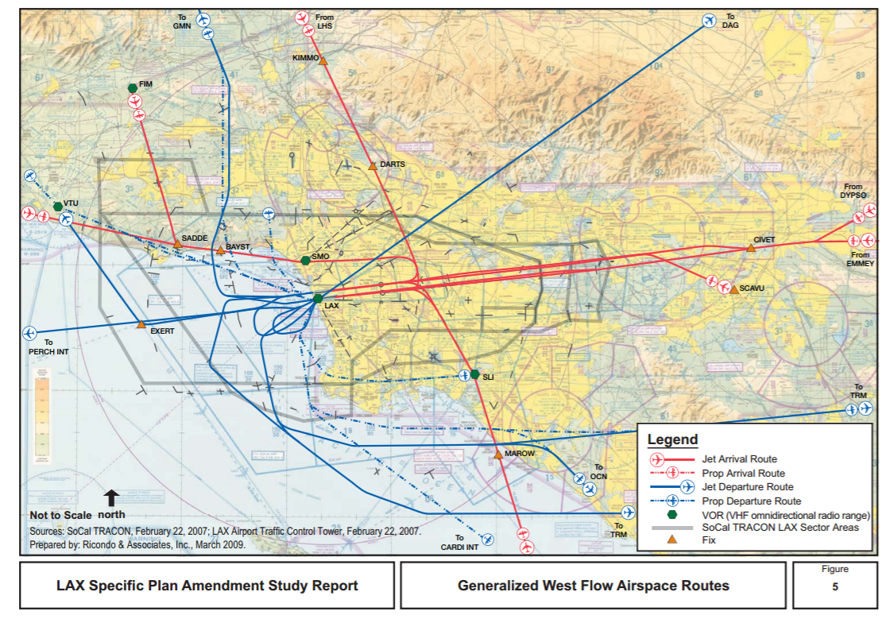

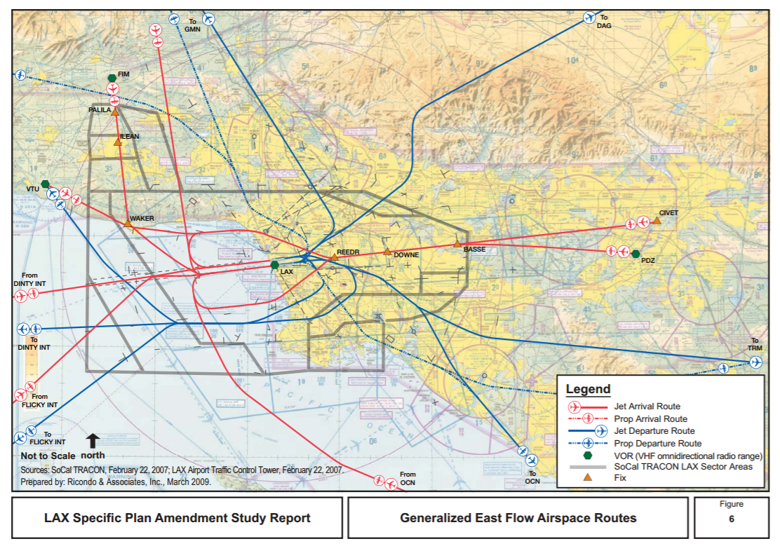

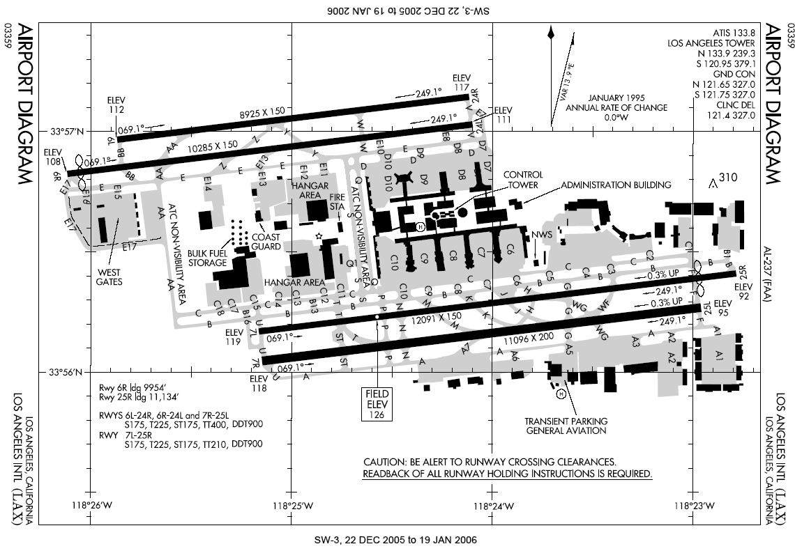

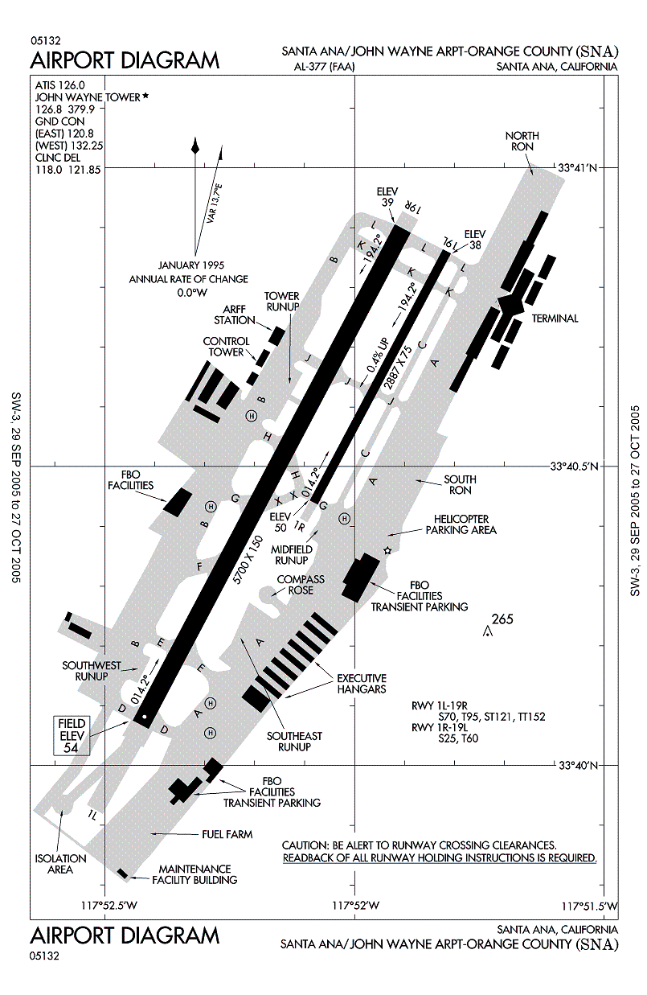

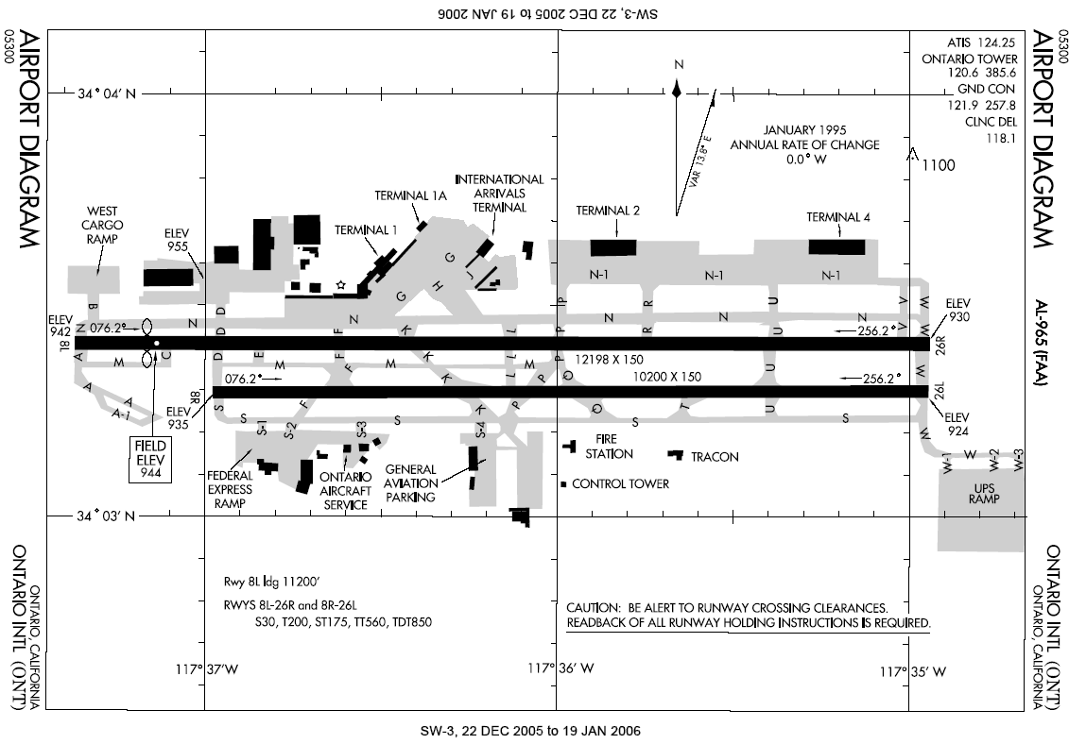

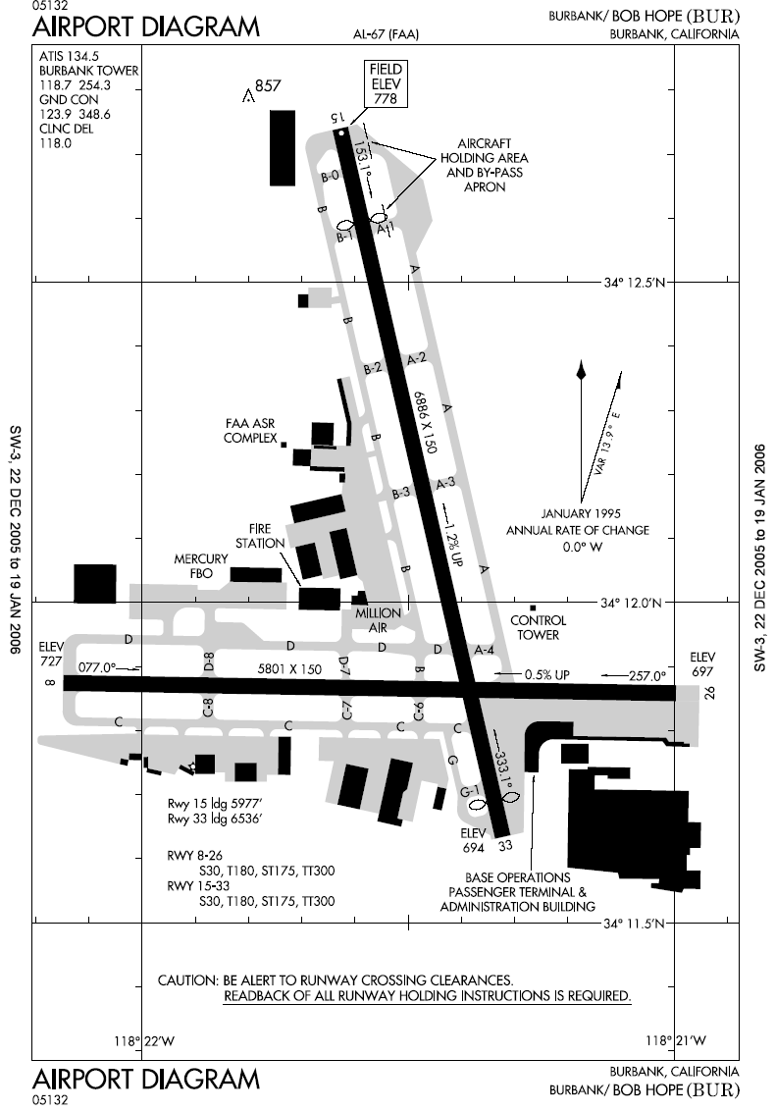

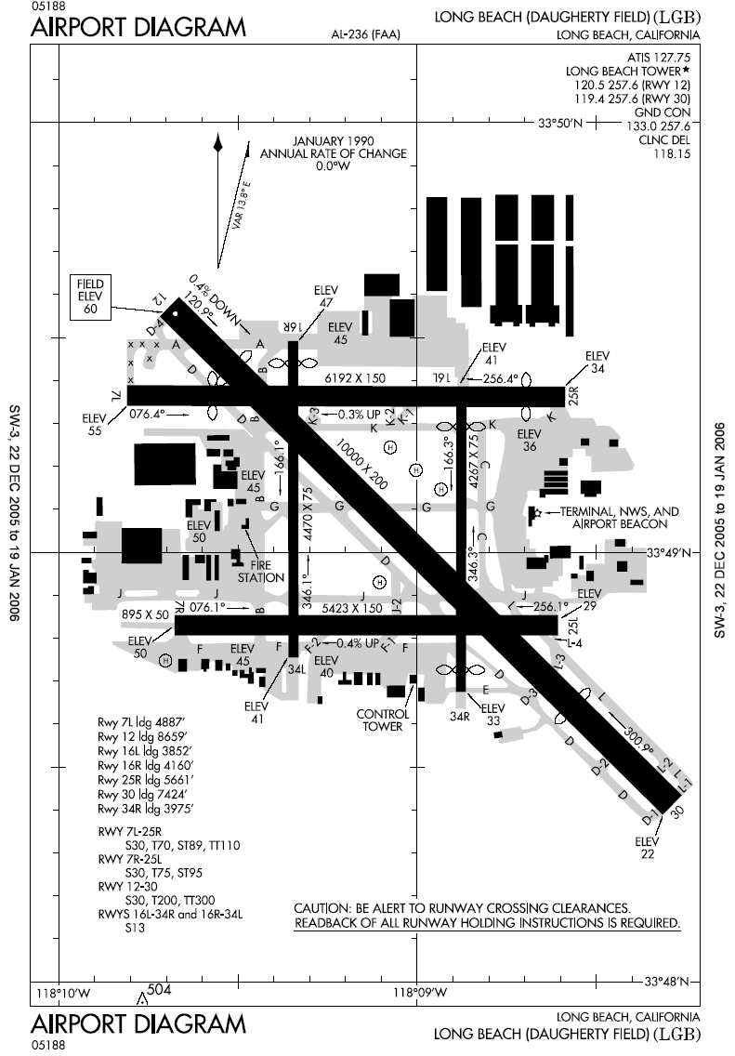

Map of the LA Basin Commercial Airports

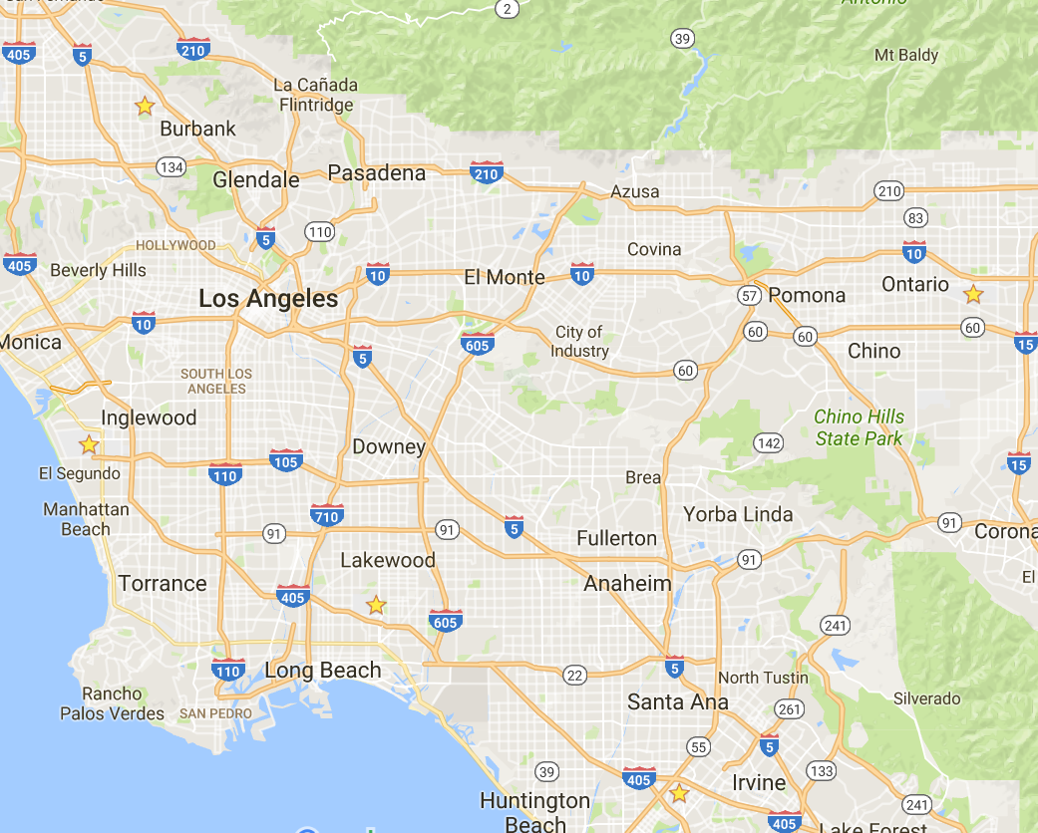

Yearly Passenger Data LAX

|  |  |  |  |
| --- | --- | --- | --- |
| Year | Departing | Arrival | Total |
| 2005 | 30,649,324 | 30,840,199 | 61,489,523 |
| 2006 | 30,499,947 | 30,540,727 | 61,040,674 |
| 2007 | 31,244,261 | 31,194,322 | 62,438,583 |
| 2008 | 29,933,581 | 29,887,169 | 59,820,750 |
| 2009 | 28,288,211 | 28,232,632 | 56,520,843 |
| 2010 | 29,605,542 | 29,464,585 | 59,070,127 |
| 2011 | 30,923,005 | 30,939,047 | 61,862,052 |
| 2012 | 31,857,135 | 31,830,986 | 63,688,121 |
| 2013 | 33,335,386 | 33,330,340 | 66,665,726 |
| 2014 | 35,320,501 | 35,343,018 | 70,663,519 |
| 2015 | 37,540,193 | 37,396,811 | 74,937,004 |